Does Variability in Defensive Pass Coverage Schemes Lead to Successful Pass Defense?

Peter Chapman
The University of Delaware
December 14, 2025
SPAX402: Predictive Analysis with Athletics Data
National Football League

Introduction and Research Question
Through the first nine weeks of the 2025 National Football League (NFL) season, the Dallas Cowboys utilized a large majority of zone coverage for their pass defense strategy. As a result, the Cowboys played very little man coverage during the opposing team’s passing plays. This complete dedication to one defensive pass coverage scheme leads to a natural research question: does high variability in the use of the major defensive pass coverage schemes correlate to better performances in key pass defense metrics? This study looks at the variability in defensive pass coverage schemes for each NFL team through the first 13 weeks of the 2025 regular season. The goal of this study is to determine whether or not a high variability in defensive pass coverage scheme usage is correlated with a successful pass defense.

Methodology
Key Pass Coverage Schemes
10 different defensive pass coverage schemes were considered for this study. These include Cover 0, Cover 1, Cover 1 Double, Cover 2, Cover 3, Quarter, Cover 6, Cover 2 Man, Cover 3 Seam, and Bracket Cover. Table 1 below details the defensive pass coverage schemes considered in this project. Some similarities exist between these 10 defensive coverage schemes, so future research could be done on a similar project that instead creates groups of similar defensive pass coverage strategies.
Coverage Name | Description
Cover 0 | A man-to-man coverage across the board with no deep defenders
Cover 1 | Any form of man defense across the board with a defensive player as a single High Man concept
Cover 1 Double | Double single High Man coverage when it is clear the defense is targeting to double one offensive receiver
Cover 2 | A two deep safety concept where any zone principle is applied; can include Tampa 2, 2 Traps, or 2 Combo/Match coverage
Cover 3 | Any 3 Deep, 4 Under concept
Quarter | Cover quarters; 4 Deep, 3 Under concept where the corners are on #1, safeties on #2, and backside safety rotation dependent on formation
Cover 6 | A quarters concept on half the field and a 2 Deep concept on the other half
Cover 2 Man | A 2 Deep safety concept where a man principle is applied; the underneath coverage will be in man across the board
Cover 3 Seam | A 3 Deep, 4 Under concept where the Curl/Flat defenders match #2 when they go vertical or out
Bracket Cover | When two offensive players have an in and out bracket by two defenders
Table 1: This table details the ten different defensive pass coverage schemes most commonly used in the NFL. Descriptions come from Pro Football Focus (PFF).

Data Collection and Transformation
Pro Football Focus (PFF) was the source of most of the data used for this project. The defensive pass coverage distribution of each NFL team in Weeks 1-13 of 2025 was collected from this site. Additionally, 2024 and 2025 defensive player grades for each team were collected. These variables were very important in the data analysis process, as described later.
2025 NFL pass defense outcomes for each team were found online from Sumer Sports. The data set from this website included two different types of defensive statistics. First, raw counting stats such as opponent pass yards, pass touchdowns, and total Expected Points Added (EPA) were collected. Second, efficiency statistics such as opponent completion percentage, EPA per play, and EPA per pass were also provided.
Data transformation consisted of four steps. First, the average pass coverage grades for cornerbacks and safeties were calculated for each NFL team using the 2024 and 2025 data. Second, the average pass rusher grade was calculated for each NFL team using the two seasons of data. Next, the defensive pass coverage variability was calculated for each NFL team in 2025, as described below. Finally, these variables were all organized into the same data set in Microsoft Excel as a .csv file.

Standardized Entropy
The first part of the analysis was to determine each team’s variability in the use of the 10 major defensive pass coverage schemes. The equation below shows the formula for standardized entropy, which was used to calculate the coverage variability for each NFL pass defense in 2025. Essentially, the frequency of each pass coverage scheme was multiplied by the natural logarithm of that frequency. These products were then added together, and the absolute value of this sum was the defensive pass coverage entropy. These entropy values, which depict the numerator in the equation below, were calculated for each NFL team in 2025. The denominator, the natural logarithm of the number of defensive pass coverage schemes (10 for this problem), standardized each value for the number of options that NFL defensive play callers (typically defensive coordinators) had to choose from. A high standardized entropy indicated high variability in defensive pass coverage scheme usage. A standardized entropy of 100% indicated perfect variability in defensive pass coverage from an NFL team in 2025.
$$\begin{aligned}{Coverage Standardized Entropy}_{Team, Year}= \\ \frac{\left|Cover 0 \%*\ln\left(Cover 0 \%\right)+Cover 1 \%*\ln\left(Cover 1 \%\right)+…+Bracket Cover \%*ln⁡(Bracket Cover \%)\right|}{\ln\left(Number of Schemes=10\right)}\end{aligned}$$

Simple Linear Regression Model
The first thought for analysis was to build a simple linear regression model between the calculated standardized entropy and a key pass defense outcome. Opponent Expected Points Added (EPA) per pass was chosen, as an efficiency statistic was preferred over a raw counting statistic such as opponent pass yards. This decision controlled for the number of passes that the opposing offense attempted. The equation below shows the proposed simple linear regression model.
$${Opponent EPA Per Pass }_{Team, Year }={β_{0}+β_{1}CoverageStandardizedEntropy}_{ Team, Year}+{ε }_{Team, Year}$$

Multiple Linear Regression Model
The standardized entropy variable, the predictor variable of interest, was also included in a multiple linear regression model to calculate the effect of defensive pass coverage variability on opponent EPA per pass. The equation below shows this multiple linear regression model. Control variables such as average pass rusher grade, average cornerback coverage grade, and average safety coverage grade were included in the model in order to isolate the effect of defensive pass coverage variability on the pass defense outcome of interest. The goal with this model was to reduce the lurking variable bias that likely existed in the simple linear regression model.
$${Opponent EPA Per Pass }_{Team, Year}={β_{0}+β_{1}CoverageStandardizedEntropy}_{Team, Year}+β_{2}{averageSafetyCoverageGrade}_{Team, Last 2 Years}+β_{3}{averageCornerCoverageGrade}_{Team, Last 2 Years}+β_{4}{averagePassRusherGrade}_{Team, Last 2 Years}+ε_{Team, Year}$$

Results and Discussion
2025 NFL Defensive Pass Coverage Standardized Entropy Distribution
Figure 1 below shows the league-wide distribution of defensive pass coverage standardized entropy through the first 13 weeks of 2025. The highest defensive pass coverage standardized entropy belonged to the Denver Broncos, who had 83.66% variability in their defensive pass coverage scheme usage during the first 13 weeks of the 2025 NFL season. The lowest defensive pass coverage standardized entropy belonged to the Las Vegas Raiders, who had just 66.43% variability in their defensive pass coverage scheme usage during the first 13 weeks. Other teams to have high defensive pass coverage variability included the Indianapolis Colts, Philadelphia Eagles, Kansas City Chiefs, and Chicago Bears. These pass defenses, especially those of the Broncos and Bears, have performed exceptionally well so far this season. This initially created the idea that high defensive pass coverage variability and pass defense success were potentially correlated with each other.
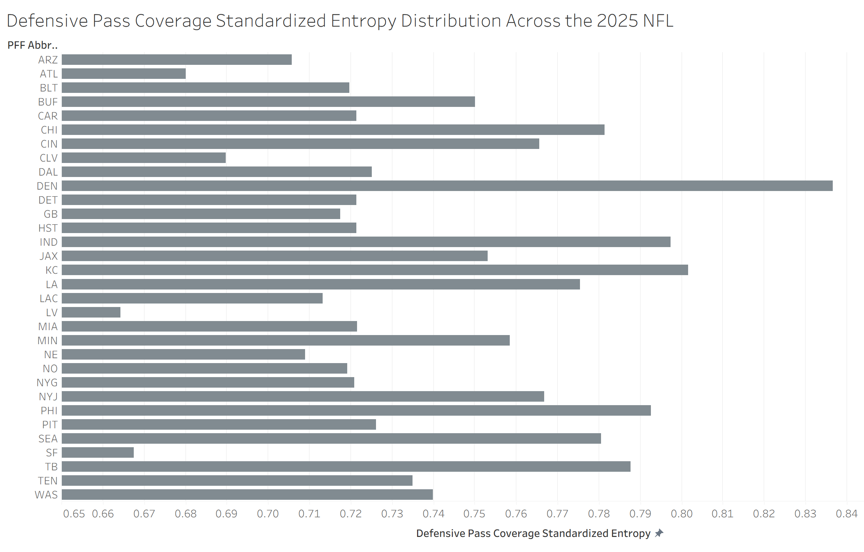
Figure 2: The league-wide distribution of defensive pass coverage standardized entropy.
Simple Linear Regression Results
Figure 3 and the equation below show the results of the simple linear regression between defensive pass coverage standardized entropy and opponent EPA per pass. As expected, the relationship between the two variables was negative. As a defense’s pass coverage variability increases, it is predicted that the opponent’s EPA per pass will decrease. Despite this, the standardized entropy variable was not statistically significant, with the p-value being 0.261051. Although the variable may not be statistically significant at most significance levels, these results may still be clinically significant in the eyes of a coach, especially a defensive coordinator. The model was also not very strong, with the R-squared being just 4.19%. This suggested that a multiple linear regression was more appropriate in order to find a model more predictive of opponent EPA per pass.
$${\hat{Opponent EPA Per Pass}}_{ Team, 2025}=0.384144 -0.498298{ Standardized Entropy }_{Team, 2025}$$
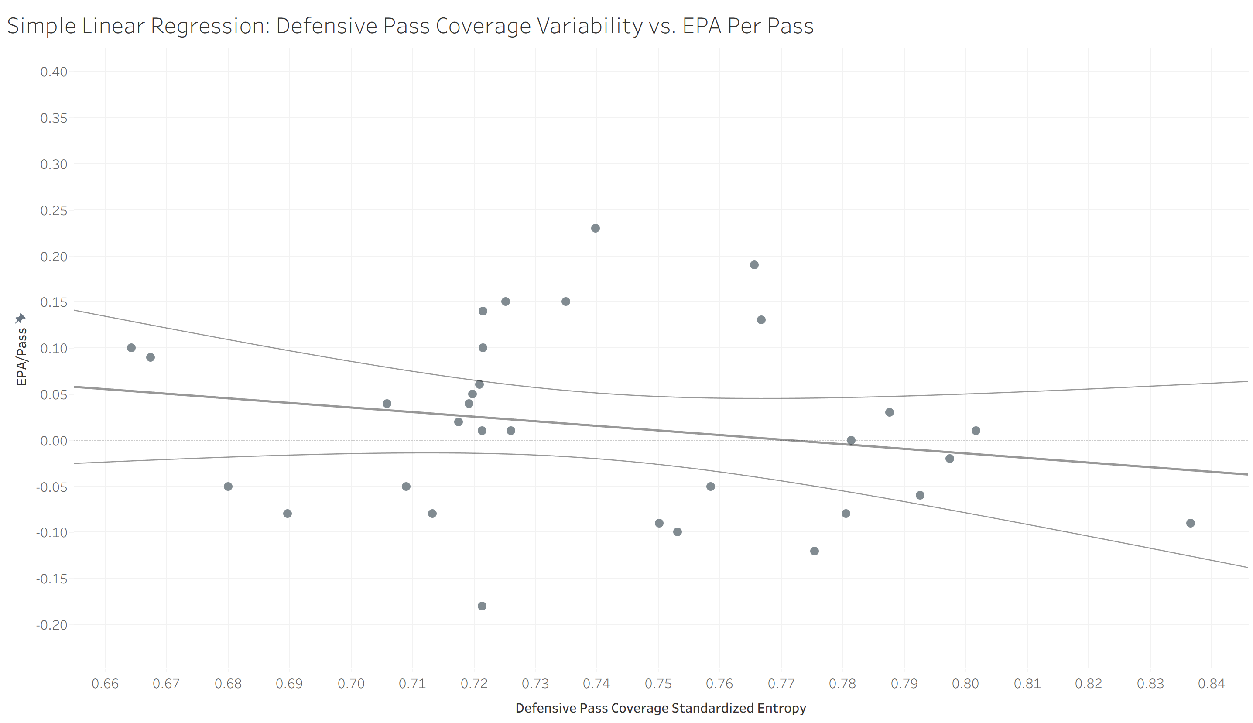
Figure 3: Simple linear regression between defensive pass coverage variability and opponent EPA per pass.

Multiple Linear Regression Results
Table 2 and the equation below show the results of the multiple linear regression that was performed. The relationship between defensive pass coverage variability and opponent EPA per pass was still negative, affirming the inverse relationship between the two variables. For this regression, the standardized entropy variable was still not statistically significant, with the p-value being 0.3559. This probability is higher than the one from the simple linear regression, which means that defensive pass coverage variability is less significant once other variables are included as predictors. Once again, this variable’s results may still be clinically significant in the eyes of a coach, especially a defensive coordinator.
The three control variables of interest also had interesting results. A team’s average cornerback coverage grade and average pass rusher grade were quite significant, especially considering the high p-values for standardized entropy and average safety coverage grade. These results suggest that having talent at cornerback and pass rusher is more important than defensive pass coverage variability, at least in the context of opponent EPA per pass.
$$\hat{{Opponent EPA Per Pass }_{Team, 2025}}={0.09764-0.3899CoverageStandardizedEntropy}_{Team, 2025}-4.66936{averageSafetyCoverageGrade}_{Team, 2024-2025}-0.71344{averageCornerCoverageGrade}_{Team, 2024-2025}-0.29354{averagePassRusherGrade}_{Team, 2024-2025}$$
Variable | Coefficient | P-Value
Coverage Standardized Entropy | -0.3899 | 0.3559
Average Safety Coverage Grade | -4.66936 | 0.5424
Average Cornerback Coverage Grade | -0.71344 | 0.0448
Average Pass Rusher Grade | -0.29354 | 0.0503
Constant | 0.09764 | 0.7729
Table 2: Multiple linear regression results for defensive pass coverage variability and the control variables.

Conclusion and Future Research
Standardized entropy was used to calculate defensive pass coverage variability for each team from Weeks 1-13 of the 2025 NFL season. The lowest defensive pass coverage variability belonged to the Las Vegas Raiders, at just 66.43% variability. The highest belonged to the Denver Broncos at 83.66%. Other strong pass defenses had high standardized entropy values, which momentarily led to the belief that defensive pass coverage variability had a strong correlation with team pass defense outcomes.
The simple and multiple linear regression models revealed similar results. Defensive pass coverage standardized entropy and opponent EPA per pass had a negative relationship. If a defense increases its variability in pass coverage usage, it is expected that their opponent’s EPA per pass will decrease. Despite this interpretation, this predictor variable was not statistically significant in either model. However, these results may still be clinically significant from a coaching perspective, especially a defensive coordinator or a defensive backs coach.
A team’s average cornerback coverage grade and average pass rusher grade were statistically significant in the multiple linear regression model. Of course, as these average positional grades improve, an opponent’s EPA per pass is predicted to decrease. Considering that these positional grades were statistically significant, and the standardized entropy variable was not, it can be concluded that positional talent on defense is more important than defensive pass coverage variability when considering opponent EPA per pass.
More research should be conducted on the multiple linear regression performed. Additional control variables such as average PFF grades on offense should be added to the model to eliminate more lurking variable bias and to create a more accurate estimate of defensive pass coverage variability’s true effect on opponent EPA per pass. Another idea is to change the dependent variable of interest to a different pass defense outcome such as interception rate (INT%) or opponent Expected Points Added (EPA) per drop back. These dependent variables may yield different results regarding the impact of defensive pass coverage variability on team pass defense outcomes.

